Unix Assignment 3  
Sebastian Main

1. A screenshot of a computer

   Description automatically generatedA computer screen shot of a computer program

   Description automatically generated
2. Unmount  
   A screenshot of a computer

   Description automatically generated

Lsblk -f (vfat)

Other commands:

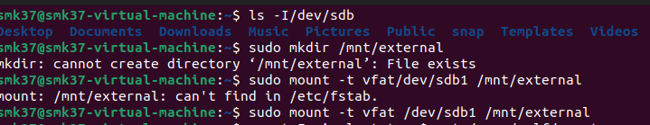

Final:

1. 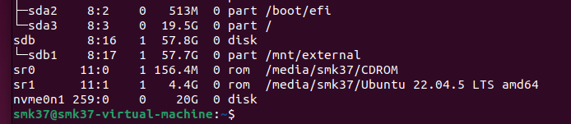
2. A screenshot of a computer screen

   Description automatically generated

PART TWO:

1. A screenshot of a video game

   Description automatically generated
2. 
3. 
4. A screen shot of a computer code

   Description automatically generated
5. And 6. 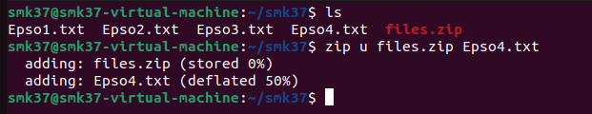

7. 